Title of your article (Please limit the title to a maximum length of 15 words)
Author Nameª* and A. N. Author^{b}
ªUniversity, Department, City, Country;
^{b}University, Department, City, Country
Provide full correspondence details here including e-mail for the *corresponding author
Repeat the title of your article here
Abstract: A concise and factual abstract is required. The abstract should state briefly the purpose of the research, the principal results and major conclusions. An abstract is often presented separately from the article, so it must be able to stand alone. For this reason, References should be avoided, but if essential, then cite the author(s) and year(s). Also, non-standard or uncommon abbreviations should be avoided, but if essential they must be defined at their first mention in the abstract itself. The abstract should not be more than 200 words.
Keywords: word; another word; lower case except names; max five keyword

Heading 1: use this style for level one headings
Paragraph: use this for the first paragraph in a section, or to continue after an extract.
New paragraph: use this style when you need to begin a new paragraph. Display quotations of over 40 words, or as needed.
- For bulleted lists
- For numbered lists
Displayed equation ( )

Heading 2: use this style for level two headings

Heading 3: use this style for level three headings
Heading 4: create the heading in italics. Run the text on after a punctuation mark.
Electronic versions of figures and tables in minimum resolutions of 300 dpi must be supplied. Both line drawings and photographs are referred to as figures. Papers with a poor quality of figures and tables will be returned to the authors. Use Times New Roman font, 9 pt, for all table entries including column and row names. Please do not use too large a font in figures; use Times New Roman font, 9 pt, if possible. Make sure that line weights, fonts, and shading are consistent throughout the paper. Figures and tables are to be numbered consecutively with Arabic numerals in the order in which they are referred to in the text, and have brief self-explanatory captions (e.g., Figure 1. Rate of use of the Industry 4.0 concepts, Table 1. Use of Industry 4.0 concepts.). Tables are numbered independently of any figures, and vice versa. Use Times New Roman font, 9 pt, for figures and tables captions. Figures and their captions should be centred. Tables and their captions should be aligned left. Put figures and tables as close as possible to their mention in the text, preferable at the top or bottom of a page.
Figure captions appear below the figures. When referring to a figure in the body of the text, the abbreviation "Figure" with a proper number is used. Table captions appear above the table. When referring to a table in the text, the word "Table" with the proper number is used. Please note that each table, irrespective of the number of columns, must have exactly the same width as is line width of the body text.

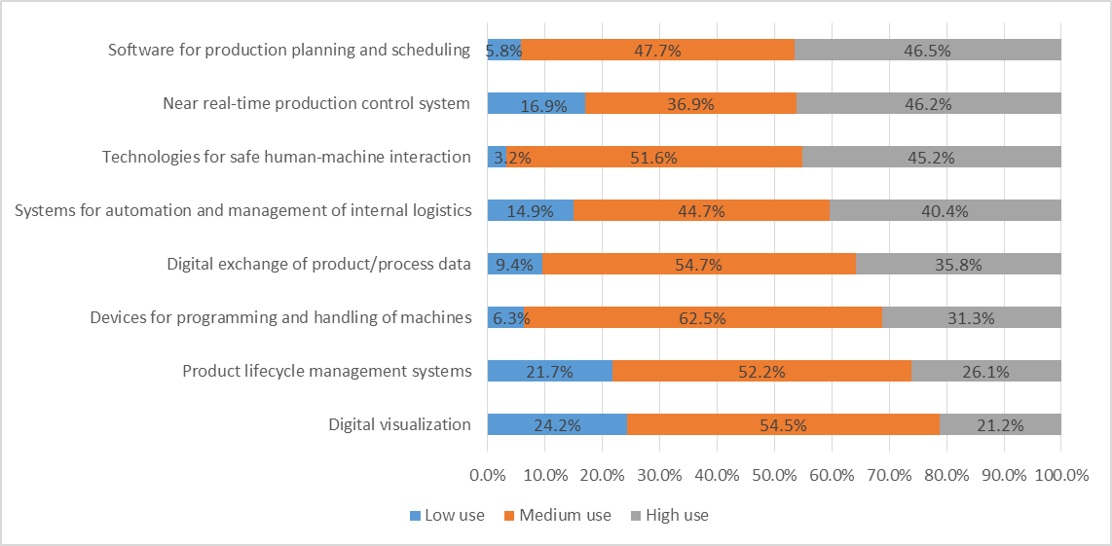
Figure 1. Rate of use of the Industry 4.0 concepts

Table 1. Use of Industry 4.0 concepts.
Industry 4.0 technology concepts | Share (%) | Rank | Planned use
Devices for programming and handling of machines | 6.8% | 8 | 9.6%
Product lifecycle management systems | 8.9% | 7 | 8.6%
Technologies for safe human-machine interaction | 11.4% | 6 | 4.3%
Digital visualization | 12.1% | 5 | 9.6%
Systems for automation and management of internal logistics | 18.6% | 4 | 10.7%
Digital exchange of product/process data | 21.4% | 3 | 9.6%
Near real-time production control system | 26.4% | 1 | 16.1%
Software for production planning and scheduling | 21.8% | 2 | 11.4%

Acknowledgements
Avoiding identifying any of the authors prior to peer review. Collate acknowledgements in a separate section at the end of the article before the references and do not, therefore, include them on the title page, as a footnote to the title or otherwise. List here those individuals who provided help during the research (e.g., providing language help, writing assistance or proof reading the article, etc.).

Funding
List funding sources in this standard way to facilitate compliance to funder's requirements. Example: This work was supported by the European Commission under the Horizon 2020 Marie Skłodowska-Curie Actions project “MAKERS: Smart Manufacturing for EU Growth and Prosperity” [grant agreement number xxxx, yyyy].
It is not necessary to include detailed descriptions on the program or type of grants and awards. When funding is from a block grant or other resources available to a university, college, or other research institution, submit the name of the institute or organization that provided the funding.
If no funding has been provided for the research, please include the following sentence: This research did not receive any specific grant from funding agencies in the public, commercial, or not-for-profit sectors.

References
A reference section must be included. Please use this IEEE reference guide when preparing your paper. Please note that authors are responsible for the accuracy and completeness of their references. All reference entries must be prepared exactly according to this instruction otherwise the paper will be returned to the authors without review. References must be numbered and ordered according to where they are first mentioned in the paper, not alphabetically.
Reference numbers are set flush left and form a column of their own, hanging out beyond the body of the reference. The reference numbers are on the line, enclosed in square brackets. In all references, the given name of the author or editor is abbreviated to the initial only and precedes the last name. Use commas around Jr., Sr., and III in names. All references, except those ending with URLs, will end with a period, including those with a DOI. However, if a reference contains both a DOI or accessed date, as well as a URL, place the DOI after the URL and end with a period. For any reference that cites two months for the same issue, the two months should be separated by a slash (e.g., Jul./Aug.), followed by the year of publication. References may not include all information; please obtain and include relevant information. Do not combine references. There must be only one reference with each number. If there is a URL included with the print reference, it can be included at the end of the reference. Examples follow.
Journal Papers
Format:
J. K. Author, “Name of paper,” Abbrev. Title of Journal, vol. x, no. x, pp. xxx–xxx, Abbrev. month, year, doi: xxx.

Example:
[1] N. Suzić, E. Sandrin, S. Suzić, C. Forza, A. Trentin, and Z. Anišić, “Implementation guidelines for mass customization: A researcher-oriented view,” Int. J. Ind. Eng. Manag., vol. 9, no. 4, pp. 229–243, Dec. 2018, doi: 10.24867/IJIEM-2018-4-229.
Books
Format:
J. K. Author, Title of the book. City of Publisher, (only U.S. State), Country: Abbrev. of Publisher, year, doi: xxx.
Example:
[2] I. Gibson, D. W. Rosen, and B. Stucker, Additive Manufacturing Technologies. New York, NY, USA: Springer, 2010, doi: 10.1007/978-1-4419-1120-9.
Book With Chapter Title
Format:
J. K. Author, “Title of chapter in the book,” in Title of Published Book, X. Editor, Ed., City of Publisher, State (only U.S.), Country: Abbrev. of Publisher, year, ch. x, sec. x, pp. xxx–xxx, doi: xxx.
Example:
[3] B. Lalic and U. Marjanovic, “Organizational readiness/preparedness,” in E-Business Issues, Challenges and Opportunities for SMEs: Driving Competitiveness, M. M. Cruz-Cunha and J. Varajão, Eds. New York, NY, USA: IGI Global, 2010, pp. 101–116, doi: 10.4018/978-1-61692-880-3.ch007
Proceedings Papers
Format:
J. K. Author, “Title of paper,” in Abbreviated Name of Conf., (location of conference is optional), year, pp. xxx–xxx, doi: xxx.
Example:
[4] N. Medic, U. Marjanovic, J. Prester, I. Palcic, and B. Lalic, “Evaluation of advanced digital technologies in manufacturing companies: Hybrid fuzzy MCDM approach,” in 25th International EurOMA Conference, Budapest, Hungary, 2018, pp. 1–10.
Websites
Format:
First Name Initial(s) Last Name. “Page Title.” Website Title. Web Address (retrieved Date Accessed).
Example:
[5] Fraunhofer Institute for Systems and Innovation Research ISI. “European Manufacturing Survey.” [Online]. Available: https://www.isi.fraunhofer.de/en/themen/industrielle-wettbewerbsfaehigkeit/fems.html#tabpanel-1. [Accessed: 14-Jul-2019].

